DBMS

LAB ASSIGNMENT - 3



Ananya Agarwal

102083036

2CO14

1. **Display the system date**

select sysdate from dual;

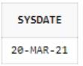

1. **Display current day**

select to_char(sysdate,'day') from dual;

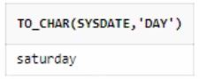

1. **Display current month and spell out year**

select to_char(sysdate,'mmsp,yyyysp') from dual;

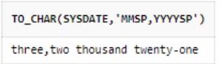

1. **Display spell out current date**

select to_char(sysdate,'ddsp') from dual;

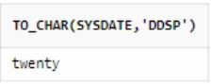

1. **Check whether it is AM or PM right now**

select to_char(sysdate,'am') from dual;

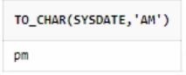

1. **Display the date of next Friday**

select next_day(sysdate,'friday') from dual;

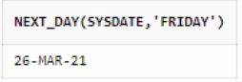

1. **Round the system date on month**

select round(sysdate,'month') from dual;

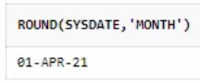

1. **Truncate the system date on month**

select trunc(sysdate,'month') from dual;

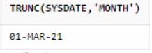

1. **Round the system date on year**

select round(sysdate,'year') from dual;

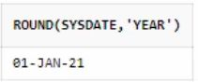

1. **Truncate the system date on year**

select trunc(sysdate,'year') from dual;

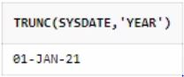

1. **Find the day after three days**

select to_char(sysdate+3,'day') from dual;

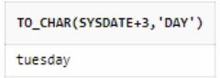

**Queries Based on EMP table**

create table employee(empno number, ename varchar2(20),doj date);

E:\4th sem\DBMS\lab\ass\table.JPG

insert into employee values(1,'Raj',to_date('2/01/2008','DD/MM/YYYY'));

insert into employee values(2,'Sham',to_date('20/05/1994','DD/MM/YYYY'));

insert into employee values(3,'abhivansh',to_date('6/07/2000','DD/MM/YYYY'));

insert into employee values(4,'Ram',to_date('1/09/2007','DD/MM/YYYY'));

insert into employee values(5,'Ananya',to_date('3/04/1995','DD/MM/YYYY'));

insert into employee values(6,'A_Agarwal',to_date('4/03/2005','DD/MM/YYYY'));

insert into employee values(7,'Geeta',to_date('3/03/2021','DD/MM/YYYY'));

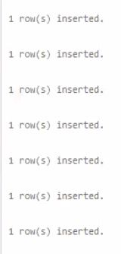

1. **Display day of date of joining column**

select to_char(doj,'day')from employee;

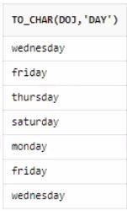

1. **Display those employees who join the company on Monday**

select ename from employee

where to_char(doj,'fmday')='monday';

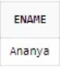

1. **Display those employees who join the company this month**

select ename from employee

where to_char(doj,'fmmonth')='march';

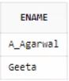

1. **Display those employees who join the company in last 30 days**

select ename from employee

where doj between sysdate -30 and sysdate;

E:\4th sem\DBMS\lab\ass\15.JPG

**Create a table train having three four columns**

1. **Train Number, date of Departure, time of departure, time of arrival**

create table train(tr_no number,do_d date,to_d timestamp,to_a timestamp);

E:\4th sem\DBMS\lab\ass\table.JPG

1. **Insert five columns in train table**

insert into Train values(1,'19-Mar-2021','19-Mar-2021 06:00:00 pm','20-Mar-2021 05:30:00 am');

insert into Train values(2,'20-Mar-2021','20-Mar-2021 01:00:00 pm','20-Mar-2021 09:00:00 pm');

insert into Train values(3,'20-Mar-2021','20-Mar-2021 04:00:00 am','22-Mar-2021 05:30:00 am');

insert into Train values(4,'19-Mar-2021','19-Mar-2021 01:00:00 pm','21-Mar-2021 07:00:00 pm');

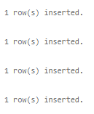

1. **Display all the records**

select * from train;

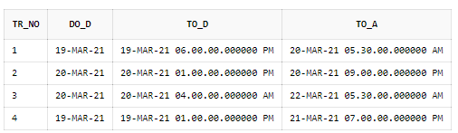

1. **Display the time values inserted in the columns**

select to_char(to_a,'HH:MI:SS'),to_char(to_d,'HH:MI:SS') from train;

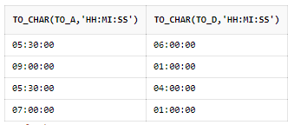

1. **Display those trains which arrived on PM**

select * from train where to_char(to_a,'pm')='pm';

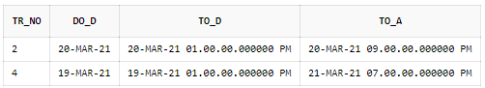

1. **Display train number who are going to depart in next on hour**

select to_char(sysdate,'HH24:MI:SS') from dual;

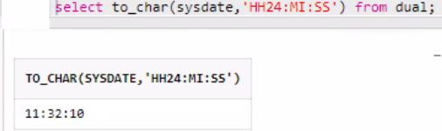

insert into Train values(1,'28-Mar-2021','28-Mar-2021 11:50:00 am','29-Mar-2021 05:30:00 am');

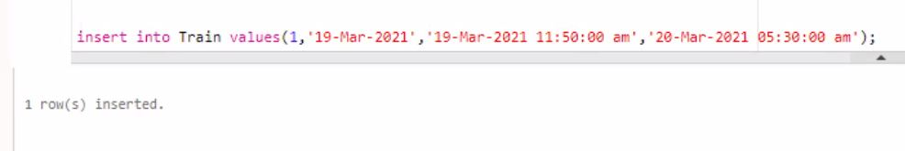

select tr_no from train where to_d between sysdate and sysdate +1/24;

